**(ML) Programming Section 5: AI Toolkits**

**Please copy files from the MATLAB Drive for this section:**[**[link here]**](https://drive.mathworks.com/sharing/8cd58cfd-6a7e-40bf-8619-358f4712139f)

## **Objectives**

* **AI Concepts:** Introduce fundamental concepts of artificial intelligence, including machine learning, deep learning, and neural networks.
* **AI Toolboxes:** Explain the role of AI toolboxes in implementing AI algorithms efficiently. ML/DL Toolboxes: Introduce popular AI toolboxes available in MATLAB, such as Deep Learning Toolbox and Machine Learning Toolbox.
* **Toolbox Purposes:** Explain the capabilities and features of each toolbox and when to use them for specific tasks.
* **AI Algorithms:** Demonstrate how to implement various AI algorithms using MATLAB's built-in functions and toolboxes.
* **Algorithm Types:** Cover a range of algorithms, including regression, classification, and deep learning.
* **Data Analysis:** Illustrate how to import and export data from external sources into MATLAB for AI analysis.
* **Real-World Examples:** Provide examples of real-world applications of AI in various domains, such as healthcare, finance, and image recognition.
* **AI Ethics:** Discuss ethical considerations in AI, including bias, fairness, and privacy concerns.
* **AI Projects:** Assign projects or hands-on exercises that allow students to apply what they've learned to solve AI problems independently.

## **Main Learning Goal**

Students will develop proficiency in using MATLAB's AI toolboxes to analyze data, implement AI algorithms, and solve real-world problems, while also gaining an understanding of ethical considerations and best practices in AI development.

## **Focus Question**

How can we leverage MATLAB's AI toolboxes to analyze data, develop AI models, and address real-world challenges, while ensuring ethical considerations are integrated into our solutions?

## **So... What is Artificial Intelligence Anyways...?**

First, we will watch a short 8-minute video that introduces the concept of **artificial intelligence**, please click on the following link to the YouTube website:

[What Is AI? | Artificial Intelligence For Beginners - Ronald van Loon (YouTube)](https://youtu.be/mQlCSPeqmrc?feature=shared)

**Let's discuss the following questions:**

1. How does AI, akin to using APIs and web scraping, gather data to suggest content?

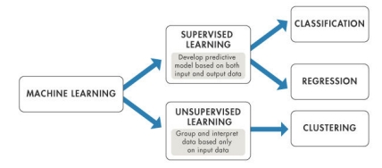

**Machine Learning, AI tools, and Analysis**

**Please copy over the files for Section 05 from the MATLAB Drive**

## The files can be found from the link given at the top of the handout: [[click here]](https://drive.mathworks.com/sharing/8cd58cfd-6a7e-40bf-8619-358f4712139f/)

For the first coding activity, please open “**ML_Sec05(Part 1)–AI_Tools_v2.mlx**”

Please follow the examples along with the instructor or the PowerPoint PDF that can be found in the same folder as this section’s code in the MATLAB Drive. After completing this live script, please continue to Part 2.

**Train A KNN Model**

## The live script for this section can be found in the same MATLAB Drive folder as above: [[click here]](https://drive.mathworks.com/sharing/8cd58cfd-6a7e-40bf-8619-358f4712139f/)

For this section you can use the hints given and the PPT to complete the given problems on your own. If you need help, the teacher or teaching assistant will be able to walk through the problem with you.

Make sure to refer back to the previous live script if you are stuck on what code to use to solve a problem!

## **What are the Impacts of Machine Learning?**

The class will watch these following videos before having a discussion:

1. [**Link: What are Neural Networks?**](https://www.youtube.com/watch?v=jmmW0F0biz0)

**[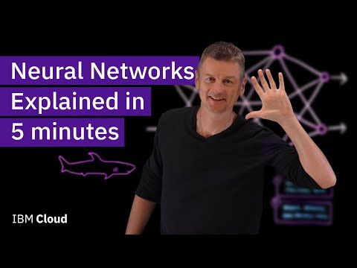](https://www.youtube.com/embed/jmmW0F0biz0?feature=oembed)**

1. **[Link : What are KNNs?](https://www.youtube.com/watch?v=0p0o5cmgLdE)**

**[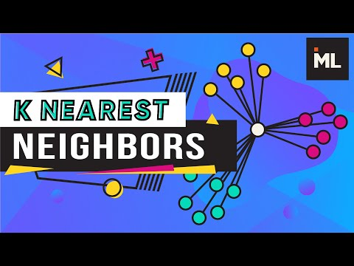](https://www.youtube.com/embed/0p0o5cmgLdE?feature=oembed)**

1. **[Link: What are CNNs?](https://www.youtube.com/watch?v=QzY57FaENXg)**

**[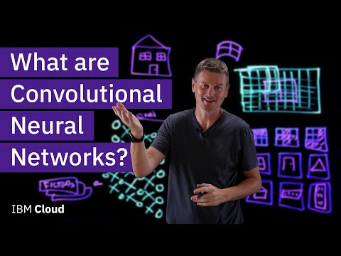](https://www.youtube.com/embed/QzY57FaENXg?feature=oembed)**

**Let’s discuss the following questions:**

1. How might the use of KNN and CNN models in decision-making processes raise ethical concerns, particularly in areas like hiring, lending, or law enforcement?
2. In what ways have KNN and CNN models revolutionized industries such as healthcare, finance, or transportation? What are the potential benefits and drawbacks of these technological advancements?
3. How do KNN and CNN algorithms contribute to the phenomenon of filter bubbles and echo chambers on social media platforms? What implications does this have for societal discourse and polarization?
4. What do you envision as the future trajectory of AI research and development, particularly in the context of KNN and CNN models? How might these technologies evolve to address emerging challenges and opportunities?